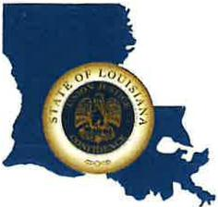 | CAPITAL AREA GROUNDWATER CONSERVATION DISTRICT
GARY I. BEARD
EXECUTIVE DIRECTOR

MEETING NOTICE
Capital Area Groundwater Conservation District
Board Meeting

WHEN: Thursday, September 21, 2023

TIME: 1:30 p.m.

WHERE: Renaissance Baton Rouge hotel
7000 Bluebonnet Blvd.
Baton Rouge, LA 70810

Contact Person: Lisa Manda, (225)293-7370

